Practical.no.2

Aim: Design a webpage that makes use of

a. Table tags

b. Form Tags (forms with various form elements)

c. Navigation across multiple pages

d. Embedded Multimedia elements

2.1 Table tags

<html>

<head>

<title>Electrycity bill</title>

</head>

<body>

<table border=1>

<tr>

<th>Month</th><th>Year</th><th>Reading</th><th>Total</th>

</tr>

<tr>

<td>June</td><td>2018</td><td>528</td><td>1000.00</td>

</tr>

<tr>

<td colspan="2">Name:<br>Sejal patil</td>

<td rowspan="2" colspan="3"><img src="C:\Users\CKT\Pictures\images.png"></td>

</tr>

<tr>

<td colspan="2">Addres:<br>panvel

</tr>

<tr>

<td colspan="4">Note:you can use paytm to pay the bill<br></td>

</tr>

<tr>

<td colspan="2">Thank you!!</td>

<td colspan="2">Any Queries call on 1234689166</td>

</tr>

</table>

</body>

</html>

Output:

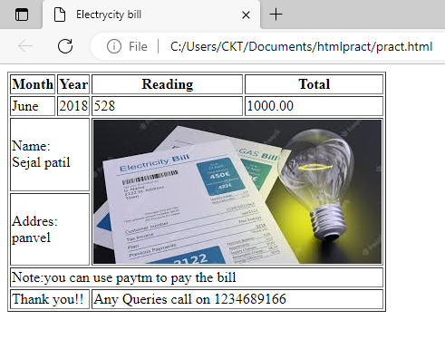

2.2 Embedded Multimedia elements

<!DOCTYPE html>

<html>

<head>

<title> audio element</title>

</head>

<body>

<h1>Playing background music</h1>

<audio src="C:\Users\CKT\Documents\htmlpract\music.mp3" controls autoplay="false">

</audio>

</body>

</html>

Output:

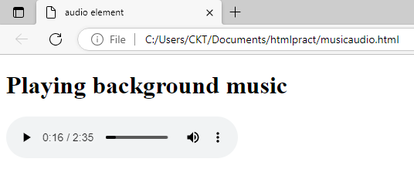

2.3 Embedded Multimedia elements

<!DOCTYPE html>

<html>

<head>

<title> audio element</title>

</head>

<body>

<h1>Playing background music</h1>

<audio src="C:\Users\CKT\Documents\htmlpract\music.mp3" controls autoplay="false">

</audio>

</body>

</html>

Output:

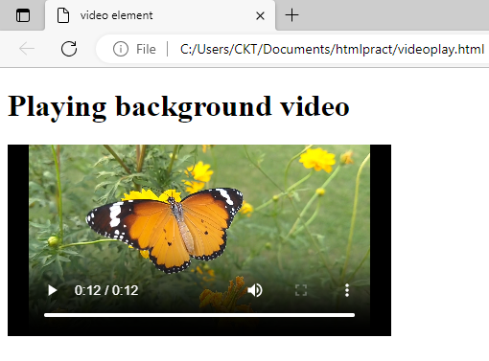

2.4 Form Tags (forms with various form elements)

<html>

<title>Paper Stack </title>

<head>

<body>

<form action="">

<div> User Fist name

<input type="text"id="lastname" />

</div>

<div> User Last name

<input type="text"id="lastname" />

</div>

<div> Contact Number

<input type="text"id="contact" />

</div>

<div> Gender:

<input type="radio"id="r" />Male

<input type="radio"id="r" />Female

</div>

<div> Hobbies:

<input type="checkbox"id="c1" />Sports

<input type="checkbox"id="c2" />Entertainment

<input type="checkbox"id="c3" />News

</div>

<div>

Country

<select>

<option>India</option>

<option>USA</option>

<option>JAPAN</option>

<option>UK</option>

</select>

</div>

<div>

<input type="reset" value="Reset" />

<input type="submit" value="login" />

</div>

</form>

</body>

Output:

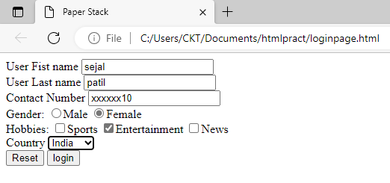

2.4

<!DOCTYPE html>

<html>

<head>

<title>Anchor tag</title>

</head>

<body>

<p>There are tow types of resources we can link to using the anchor atg: internal and external</p>

<ol type="1" start="1">

<li> <a name="internal"></a><b>Internal link:</b>also know as local links because it links to <br>

the pages to which other are part of the same website.<br>

Internal links point pages of same website. <br>

These are used to add navigation menus into the website <br>

through which user can navigate in website. </li>

<li><a name="external"></a> <b>External link:</b> External links point to web pages of other websites.<br>

External links are used by web developers because it helps<br>

to increase the SERP ranking of linked website for search terms.<br>

So, remember that linking the competitors' webpage to our<br>

website should increase popularity of your competitors' website.<li>

</ol>

<a href= "/example.html#internal">WELCOME TO MY HTML CODE <br> </a>

<a href= "https://www.google.com">WELCOME TO GOOGLE PAGE</a>

</body>

</html>

Output:

